Orthogonal Projection
# Source: AI Source: Provided by: [Data Path: Persons Table -> ID Column: 1, Name_En Column: Motasem Essam] -> From: [ChatGPT] on [7/25/2026]
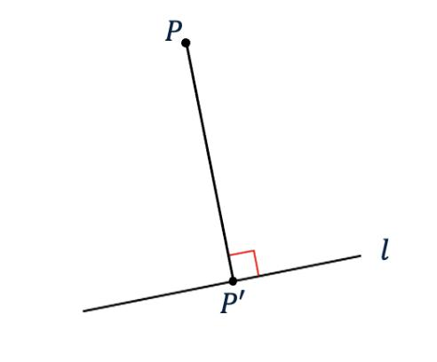
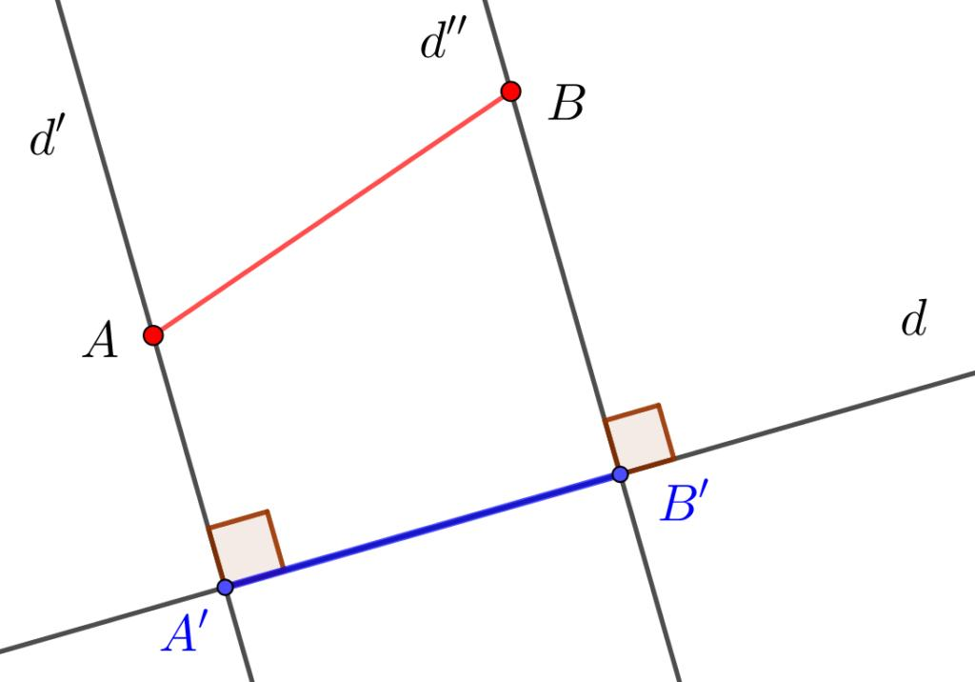
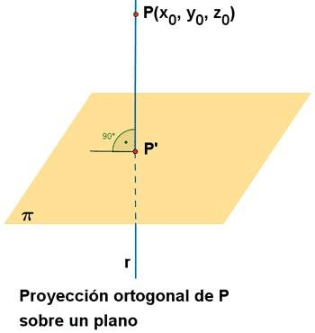

Definition
# Source: AI Source: Provided by: [Data Path: Persons Table -> ID Column: 1, Name_En Column: Motasem Essam] -> From: [ChatGPT] on [7/25/2026]
Orthogonal Projection is a type of geometric projection in which each point of an object is projected onto another line, plane, or geometric object along a perpendicular direction.
In simple terms:
An orthogonal projection maps an object onto another geometric object using projection lines that are perpendicular to the target.
For a point $P$ projected onto a line $l$, the projection point $P^{'}$ satisfies:
$$\boxed{PP^{'}⟂l}$$
Here:
- $P$ → original point
- $P^{'}$ → orthogonal projection of $P$
- $l$ → target line
- $PP^{'}$ → projection line

Purpose
# Source: AI Source: Provided by: [Data Path: Persons Table -> ID Column: 1, Name_En Column: Motasem Essam] -> From: [ChatGPT] on [7/25/2026]
Orthogonal projection is used to:
- Represent three-dimensional objects on two-dimensional surfaces.
- Find the shortest distance from a point to a line or plane.
- Determine the foot of a perpendicular.
- Find the projected length of a segment.
- Represent objects accurately in technical drawings.
- Solve geometry and vector problems.
- Convert spatial information into a simpler representation.

Basic Configuration
# Source: AI Source: Provided by: [Data Path: Persons Table -> ID Column: 1, Name_En Column: Motasem Essam] -> From: [ChatGPT] on [7/25/2026]
Consider a point $P$ and a line $l$.
Drop a perpendicular from $P$ to $l$, meeting the line at $P^{'}$:
$P$ $|$ $|$ $P^{'} → l$
Since:
$$PP^{'}⟂l$$
$P^{'}$ is the orthogonal projection of $P$ onto $l$.

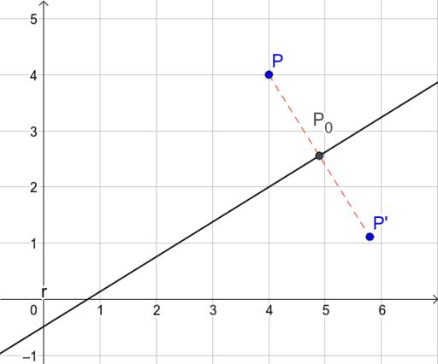
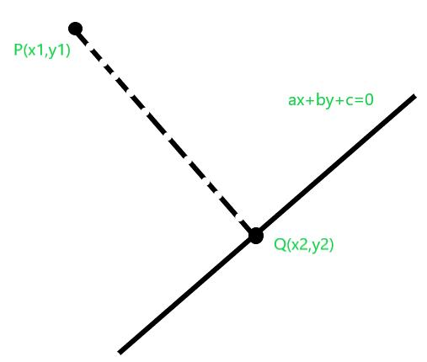

Fundamental Elements
# Source: AI Source: Provided by: [Data Path: Persons Table -> ID Column: 1, Name_En Column: Motasem Essam] -> From: [ChatGPT] on [7/25/2026]
An orthogonal projection involves three main elements:

1. Original Object
# Source: AI Source: Provided by: [Data Path: Persons Table -> ID Column: 1, Name_En Column: Motasem Essam] -> From: [ChatGPT] on [7/25/2026]
The object being projected.
It can be:
- A point.
- A line segment.
- A geometric figure.
- A three-dimensional object.
- A vector.

2. Projection Target
# Source: AI Source: Provided by: [Data Path: Persons Table -> ID Column: 1, Name_En Column: Motasem Essam] -> From: [ChatGPT] on [7/25/2026]
The object onto which the projection is made.
It can be:
- A line.
- A plane.
- A coordinate axis.
- Another geometric surface.

3. Perpendicular Projection Direction
# Source: AI Source: Provided by: [Data Path: Persons Table -> ID Column: 1, Name_En Column: Motasem Essam] -> From: [ChatGPT] on [7/25/2026]
The projection direction is perpendicular to the target.
Therefore:
$$\boxed{\text{Projection direction}⟂\text{target}}$$

Orthogonal Projection of a Point onto a Line
# Source: AI Source: Provided by: [Data Path: Persons Table -> ID Column: 1, Name_En Column: Motasem Essam] -> From: [ChatGPT] on [7/25/2026]
If $P$ is projected onto line $l$ at $P^{'}$:
$$\boxed{PP^{'}⟂l}$$
The point $P^{'}$ is called the foot of the perpendicular.
An important property is:
$$\boxed{PP^{'}=\text{shortest distance from }P\text{ to }l}$$
Among all possible segments connecting $P$ to points on $l$, the perpendicular segment has the smallest length.

Orthogonal Projection of a Line Segment
# Source: AI Source: Provided by: [Data Path: Persons Table -> ID Column: 1, Name_En Column: Motasem Essam] -> From: [ChatGPT] on [7/25/2026]
Suppose segment $\overline{AB}$ is projected onto a line $l$.
Let:
- $A^{'}$ = projection of $A$
- $B^{'}$ = projection of $B$
Then the projection of $\overline{AB}$ is:
$\boxed{\overline{A^{'}B^{'}}}$
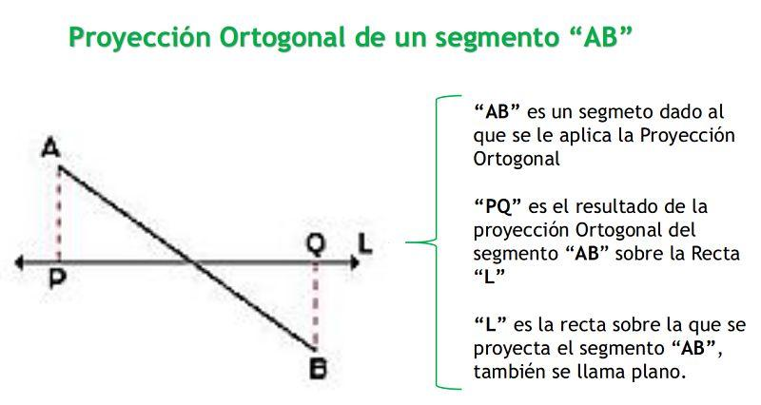
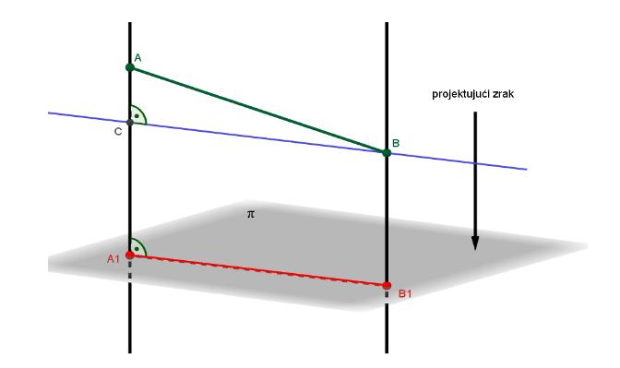
If the angle between $\overline{AB}$ and the target line is $θ$, then:
$$\boxed{A^{'}B^{'}=AB|cosθ|}$$
If $0^{∘}≤θ≤{90}^{∘}$, this is simply:
$$\boxed{A^{'}B^{'}=ABcosθ}$$

Example 1 — Projection of a Segment
# Source: AI Source: Provided by: [Data Path: Persons Table -> ID Column: 1, Name_En Column: Motasem Essam] -> From: [ChatGPT] on [7/25/2026]
Suppose:
$$AB=10$$
and the angle between $AB$ and the projection line is:
$$θ={60}^{∘}$$
Then:
$$A^{'}B^{'}=ABcos{60}^{∘}$$
Since:
$$cos{60}^{∘}=\frac{1}{2}$$
we get:
$$A^{'}B^{'}=10\left(\frac{1}{2}\right)$$
Therefore:
$$\boxed{A^{'}B^{'}=5}$$

Example 2 — Projection onto a Horizontal Line
# Source: AI Source: Provided by: [Data Path: Persons Table -> ID Column: 1, Name_En Column: Motasem Essam] -> From: [ChatGPT] on [7/25/2026]
Suppose:
$$A=(2,5)$$
and:
$$B=(8,9)$$
The orthogonal projection onto the $x$-axis is obtained by setting the $y$-coordinate to zero.
Therefore:
$$A^{'}=(2,0)$$
and:
$$B^{'}=(8,0)$$
The projected segment has length:
$A^{'}B^{'}=|8-2|$ $\boxed{A^{'}B^{'}=6}$

Orthogonal Projection onto Coordinate Axes
# Source: AI Source: Provided by: [Data Path: Persons Table -> ID Column: 1, Name_En Column: Motasem Essam] -> From: [ChatGPT] on [7/25/2026]
For a point:
$$P=(x,y)$$

Projection onto the $x$-axis
# Source: AI Source: Provided by: [Data Path: Persons Table -> ID Column: 1, Name_En Column: Motasem Essam] -> From: [ChatGPT] on [7/25/2026]
$$\boxed{P_{x}=(x,0)}$$

Projection onto the $y$-axis
# Source: AI Source: Provided by: [Data Path: Persons Table -> ID Column: 1, Name_En Column: Motasem Essam] -> From: [ChatGPT] on [7/25/2026]
$$\boxed{P_{y}=(0,y)}$$
For example:
$$P=(4,7)$$
Projection onto the $x$-axis:
$$\boxed{P_{x}=(4,0)}$$
Projection onto the $y$-axis:
$$\boxed{P_{y}=(0,7)}$$

Vector Orthogonal Projection
# Source: AI Source: Provided by: [Data Path: Persons Table -> ID Column: 1, Name_En Column: Motasem Essam] -> From: [ChatGPT] on [7/25/2026]
Orthogonal projection is particularly important in vector geometry.
Let:
$$\vec{a}$$
be projected onto:
$$\vec{b}$$
The vector projection of $\vec{a}$ onto $\vec{b}$ is:
$$\boxed{{proj}_{\vec{b}}\vec{a}=\frac{\vec{a}⋅\vec{b}}{∥\vec{b}∥^{2}}\vec{b}}$$
The scalar projection is:
$$\boxed{{comp}_{\vec{b}}\vec{a}=\frac{\vec{a}⋅\vec{b}}{∥\vec{b}∥}}$$
The scalar projection represents the signed length of $\vec{a}$ in the direction of $\vec{b}$.

Example 3 — Vector Projection
# Source: AI Source: Provided by: [Data Path: Persons Table -> ID Column: 1, Name_En Column: Motasem Essam] -> From: [ChatGPT] on [7/25/2026]
Let:
$$\vec{a}=(3,4)$$
and:
$$\vec{b}=(1,0)$$
First calculate the dot product:
$\vec{a}⋅\vec{b}=(3)(1)+(4)(0)$ $=3$
Also:
$$∥\vec{b}∥^{2}=1^{2}+0^{2}=1$$
Therefore:
${proj}_{\vec{b}}\vec{a}=\frac{3}{1}(1,0)$ $\boxed{{proj}_{\vec{b}}\vec{a}=(3,0)}$
The vector's horizontal component is $3$.

Orthogonal Projection of a Triangle
# Source: AI Source: Provided by: [Data Path: Persons Table -> ID Column: 1, Name_En Column: Motasem Essam] -> From: [ChatGPT] on [7/25/2026]
Orthogonal projection appears naturally in triangles.
If vertex $A$ is projected orthogonally onto side $BC$, the projection point $D$ satisfies:
$$\boxed{AD⟂BC}$$
Therefore, $D$ is the foot of the altitude from $A$.

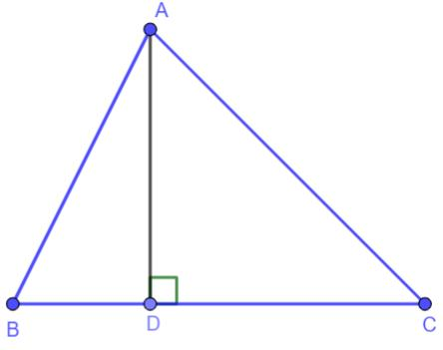
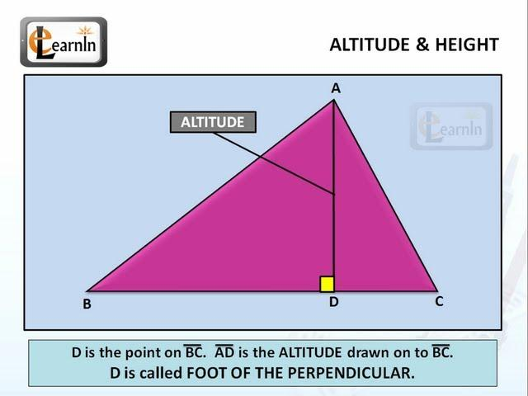
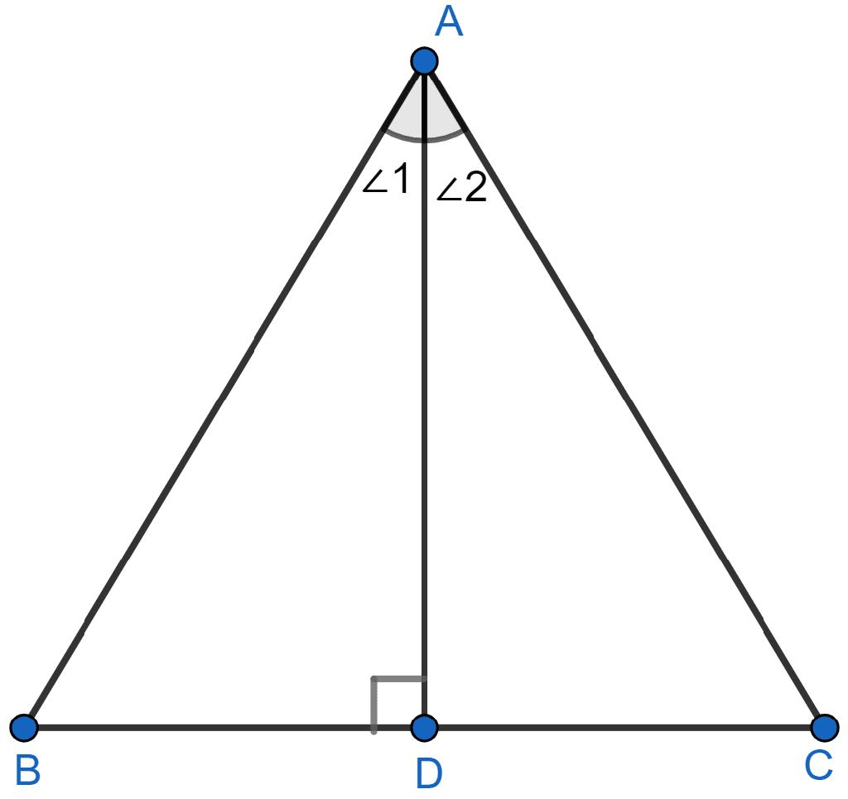
Thus:
$$\boxed{\text{Orthogonal projection of a vertex onto the opposite side}=\text{foot of the altitude}}$$
This is an important connection between projection and triangle altitude.

Orthogonal Projection onto a Plane
# Source: AI Source: Provided by: [Data Path: Persons Table -> ID Column: 1, Name_En Column: Motasem Essam] -> From: [ChatGPT] on [7/25/2026]
Orthogonal projection also works in three dimensions.
Suppose a point $P$ is projected onto a plane $Π$.
The projection point $P^{'}$ satisfies:
$$\boxed{PP^{'}⟂Π}$$
The segment $PP^{'}$ represents the shortest distance from $P$ to the plane.

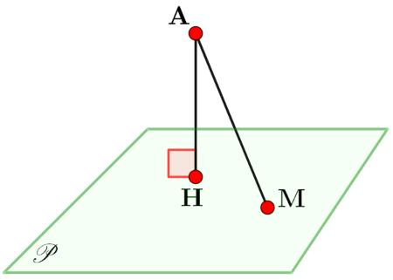
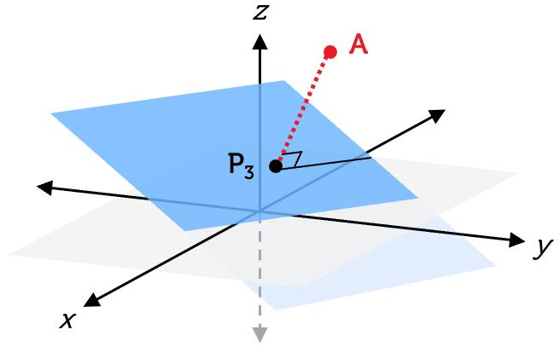
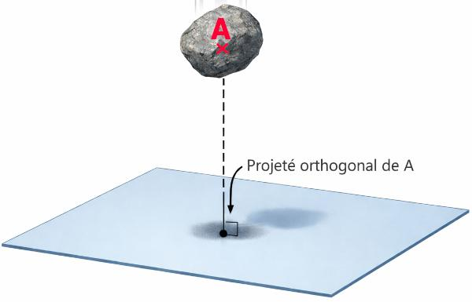
5

Orthogonal Projection in 3D
# Source: AI Source: Provided by: [Data Path: Persons Table -> ID Column: 1, Name_En Column: Motasem Essam] -> From: [ChatGPT] on [7/25/2026]
Orthogonal projection is fundamental in technical drawing and engineering graphics.
A three-dimensional object can be projected onto different planes, such as:
- Front plane.
- Top plane.
- Side plane.
These produce different views of the same object.
For example:
$$\boxed{\text{Front View}}$$
$$\boxed{\text{Top View}}$$
$$\boxed{\text{Side View}}$$
This is called orthographic projection.

Orthogonal Projection vs. Orthographic Projection
# Source: AI Source: Provided by: [Data Path: Persons Table -> ID Column: 1, Name_En Column: Motasem Essam] -> From: [ChatGPT] on [7/25/2026]
These terms are closely related but should not be treated as exactly identical.

Orthogonal Projection
# Source: AI Source: Provided by: [Data Path: Persons Table -> ID Column: 1, Name_En Column: Motasem Essam] -> From: [ChatGPT] on [7/25/2026]
A general mathematical concept where projection occurs perpendicular to the target.

Orthographic Projection
# Source: AI Source: Provided by: [Data Path: Persons Table -> ID Column: 1, Name_En Column: Motasem Essam] -> From: [ChatGPT] on [7/25/2026]
A systematic technical-drawing method that uses orthogonal projection to represent objects through standard views.
Therefore:
$$\boxed{\text{Orthographic Projection uses Orthogonal Projection}}$$

Important Properties

1. Projection lines are perpendicular
# Source: AI Source: Provided by: [Data Path: Persons Table -> ID Column: 1, Name_En Column: Motasem Essam] -> From: [ChatGPT] on [7/25/2026]
$$\boxed{PP^{'}⟂l}$$
or, for a plane:
$$\boxed{PP^{'}⟂Π}$$

2. It gives the shortest distance
# Source: AI Source: Provided by: [Data Path: Persons Table -> ID Column: 1, Name_En Column: Motasem Essam] -> From: [ChatGPT] on [7/25/2026]
For a point and a line:
$$\boxed{PP^{'}=min\{PQ:Q∈l\}}$$

3. It generally does not preserve length
# Source: AI Source: Provided by: [Data Path: Persons Table -> ID Column: 1, Name_En Column: Motasem Essam] -> From: [ChatGPT] on [7/25/2026]
If a segment is not parallel to the target:
$$A^{'}B^{'}<AB$$
in the usual non-degenerate case.

4. A segment parallel to the target preserves its length
# Source: AI Source: Provided by: [Data Path: Persons Table -> ID Column: 1, Name_En Column: Motasem Essam] -> From: [ChatGPT] on [7/25/2026]
If:
$$AB∥l$$
then:
$$\boxed{A^{'}B^{'}=AB}$$

5. A perpendicular segment can project to a point
# Source: AI Source: Provided by: [Data Path: Persons Table -> ID Column: 1, Name_En Column: Motasem Essam] -> From: [ChatGPT] on [7/25/2026]
If:
$$AB⟂l$$
then both endpoints can project to the same point, so:
$$\boxed{A^{'}B^{'}=0}$$

Special Cases

Segment Parallel to Projection Line
# Source: AI Source: Provided by: [Data Path: Persons Table -> ID Column: 1, Name_En Column: Motasem Essam] -> From: [ChatGPT] on [7/25/2026]
If:
$$AB∥l$$
then:
$$θ=0^{∘}$$
and:
$$A^{'}B^{'}=ABcos0^{∘}$$
Therefore:
$$\boxed{A^{'}B^{'}=AB}$$

Segment Perpendicular to Projection Line
# Source: AI Source: Provided by: [Data Path: Persons Table -> ID Column: 1, Name_En Column: Motasem Essam] -> From: [ChatGPT] on [7/25/2026]
If:
$$AB⟂l$$
then:
$$θ={90}^{∘}$$
and:
$$A^{'}B^{'}=ABcos{90}^{∘}$$
Therefore:
$$\boxed{A^{'}B^{'}=0}$$
The entire segment projects onto a single point.

Relationship with Related Concepts
# Source: AI Source: Provided by: [Data Path: Persons Table -> ID Column: 1, Name_En Column: Motasem Essam] -> From: [ChatGPT] on [7/25/2026]
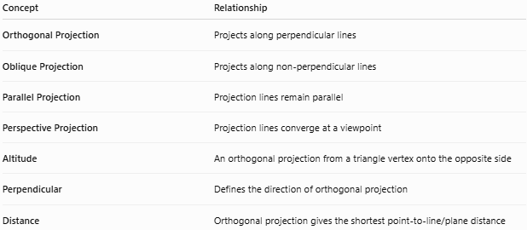
Concept | Relationship
Orthogonal Projection | Projects along perpendicular lines
Oblique Projection | Projects along non-perpendicular lines
Parallel Projection | Projection lines remain parallel
Perspective Projection | Projection lines converge at a viewpoint
Altitude | An orthogonal projection from a triangle vertex onto the opposite side
Perpendicular | Defines the direction of orthogonal projection
Distance | Orthogonal projection gives the shortest point-to-line/plane distance

Orthogonal vs. Other Projections
# Source: AI Source: Provided by: [Data Path: Persons Table -> ID Column: 1, Name_En Column: Motasem Essam] -> From: [ChatGPT] on [7/25/2026]
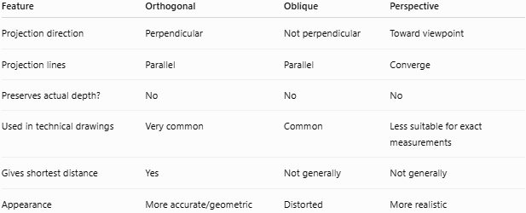
Feature | Orthogonal | Oblique | Perspective
Projection direction | Perpendicular | Not perpendicular | Toward viewpoint
Projection lines | Parallel | Parallel | Converge
Preserves actual depth? | No | No | No
Used in technical drawings | Very common | Common | Less suitable for exact measurements
Gives shortest distance | Yes | Not generally | Not generally
Appearance | More accurate/geometric | Distorted | More realistic

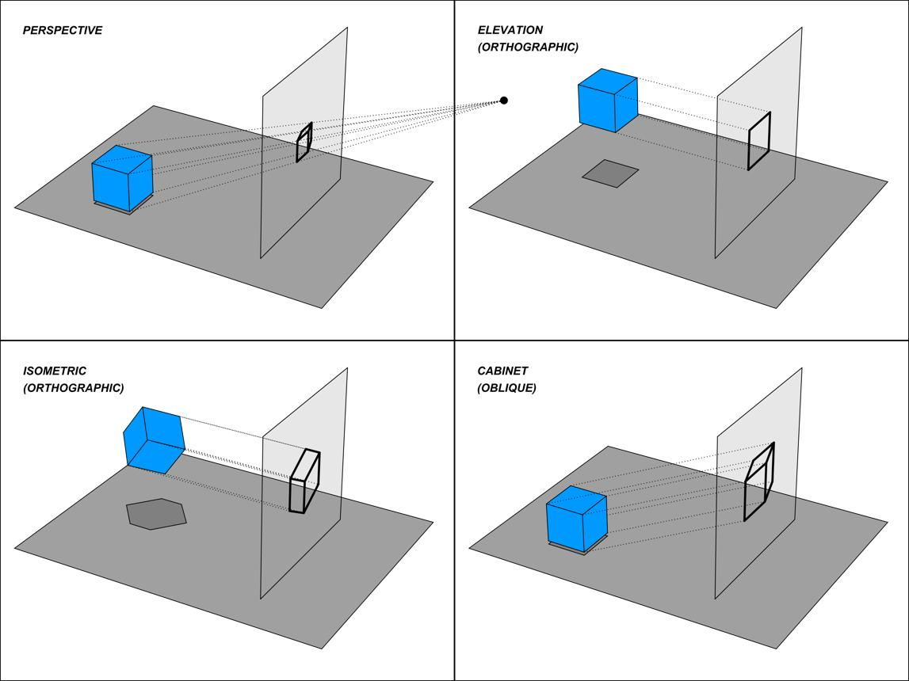
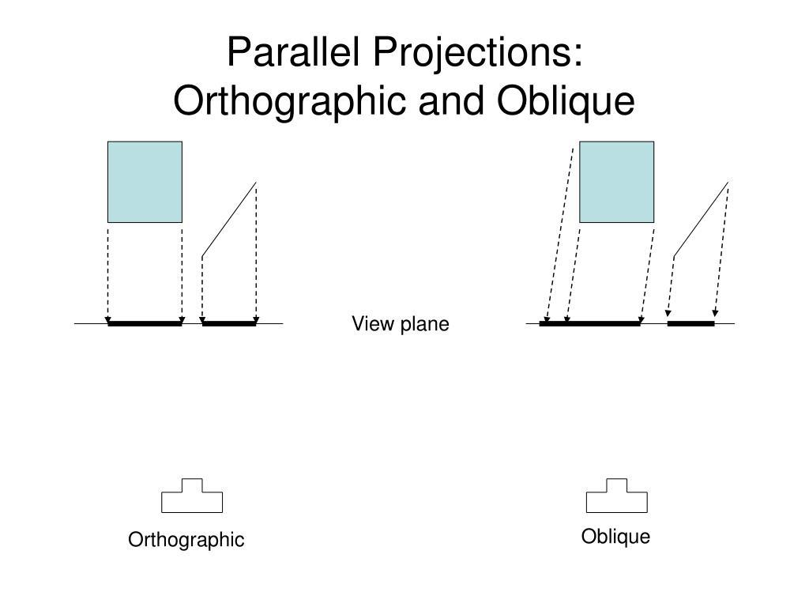
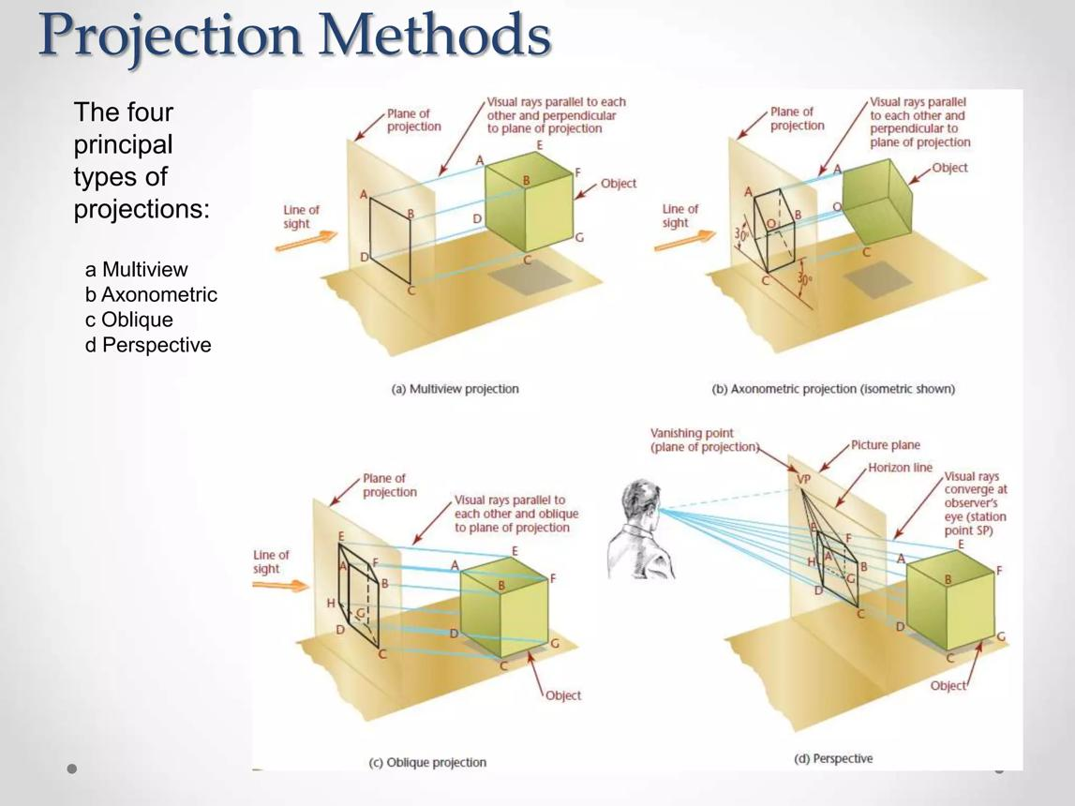
5

Applications
# Source: AI Source: Provided by: [Data Path: Persons Table -> ID Column: 1, Name_En Column: Motasem Essam] -> From: [ChatGPT] on [7/25/2026]
Orthogonal projection is used in:
- Engineering drawings — front, top, and side views.
- Architecture — plans and elevations.
- Computer graphics — non-perspective camera views.
- Geometry — perpendicular distances and constructions.
- Vector mathematics — vector components and projections.
- Physics — resolving forces into components.
- Robotics — spatial positioning.
- Surveying — mapping and measurements.
- Technical drafting — accurate representation of objects.

Advantages
# Source: AI Source: Provided by: [Data Path: Persons Table -> ID Column: 1, Name_En Column: Motasem Essam] -> From: [ChatGPT] on [7/25/2026]
- Provides mathematically precise projections.
- Produces the shortest distance to a line or plane.
- Useful for exact technical measurements.
- Easy to analyze mathematically.
- Important for vector calculations.
- Provides standard views of 3D objects.
- Does not require a perspective viewpoint.

Limitations
# Source: AI Source: Provided by: [Data Path: Persons Table -> ID Column: 1, Name_En Column: Motasem Essam] -> From: [ChatGPT] on [7/25/2026]
- It can lose depth information.
- A 3D object may appear flattened.
- Lengths are not generally preserved.
- Angles are not generally preserved.
- Different 3D objects can have the same projection.
- It may be less visually realistic than perspective projection.

Comparison with Geometric Transformations
# Source: AI Source: Provided by: [Data Path: Persons Table -> ID Column: 1, Name_En Column: Motasem Essam] -> From: [ChatGPT] on [7/25/2026]
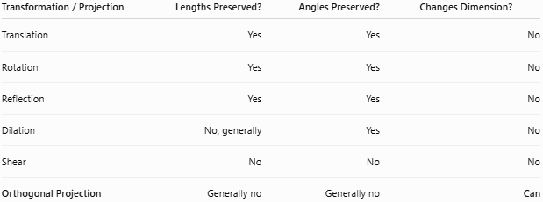
Transformation / Projection | Lengths Preserved? | Angles Preserved? | Changes Dimension?
Translation | Yes | Yes | No
Rotation | Yes | Yes | No
Reflection | Yes | Yes | No
Dilation | No, generally | Yes | No
Shear | No | No | No
Orthogonal Projection | Generally no | Generally no | Can
This is why orthogonal projection is different from the classical rigid transformations.

Key Points
# Source: AI Source: Provided by: [Data Path: Persons Table -> ID Column: 1, Name_En Column: Motasem Essam] -> From: [ChatGPT] on [7/25/2026]
- Orthogonal projection projects an object onto another object using a perpendicular direction.
- For a point $P$ projected onto a line $l$:
$$\boxed{PP^{'}⟂l}$$
- The projection point is the foot of the perpendicular.
- Orthogonal projection gives the shortest distance from a point to a line or plane.
- For a segment:
$$\boxed{A^{'}B^{'}=AB|cosθ|}$$
- Projection onto the $x$-axis:
$$\boxed{(x,y)→(x,0)}$$
- Projection onto the $y$-axis:
$$\boxed{(x,y)→(0,y)}$$
- Vector projection:
$$\boxed{{proj}_{\vec{b}}\vec{a}=\frac{\vec{a}⋅\vec{b}}{∥\vec{b}∥^{2}}\vec{b}}$$
- In a triangle, the orthogonal projection of a vertex onto the opposite side gives the foot of the altitude.
- Orthographic projection is an important practical application of orthogonal projection in technical drawing.

Conclusion
# Source: AI Source: Provided by: [Data Path: Persons Table -> ID Column: 1, Name_En Column: Motasem Essam] -> From: [ChatGPT] on [7/25/2026]
Orthogonal Projection is a geometric projection in which the projection direction is perpendicular to the target:
$$\boxed{\text{Projection direction}⟂\text{target}}$$
For a point $P$ projected onto a line $l$:
$$\boxed{PP^{'}⟂l}$$
It is fundamental to geometry, vectors, engineering drawing, architecture, computer graphics, physics, and technical visualization. It is particularly important because the perpendicular projection provides the shortest distance between a point and a line or plane.
Is this conversation helpful so far?

